WEEK 2 TASK
Exploratory Data Analysis (EDA) and Visualization Framework Design
Applied Context:
Crop Yield Dataset (Weather, Soil & Historical Yield Records)
Data Science Internship – EDA & Visualization Framework Report

1. Introduction to EDA
Exploratory Data Analysis (EDA) is the process of investigating a dataset to summarize its main characteristics, uncover patterns, spot anomalies, and test assumptions — typically through visual and statistical methods — before any formal modeling begins. It acts as the bridge between raw, unprocessed data and a reliable machine learning pipeline.
Why EDA matters: Skipping EDA risks feeding a model data with hidden errors, misleading correlations, or unaddressed biases, all of which quietly undermine downstream predictions. A rigorous EDA phase builds the intuition needed to make informed choices later about feature engineering, model selection, and evaluation metrics.
This framework is designed to be dataset-agnostic — while it is illustrated using a hypothetical crop yield dataset (combining weather, soil, and historical yield records) for concreteness, every technique and tool described below applies equally to any structured, tabular dataset.

2. Data Exploration Techniques

2.1 Data Types Overview
- Numerical (continuous): e.g., rainfall in mm, temperature in °C, yield in tonnes/hectare.
- Numerical (discrete): e.g., number of sowing days, count of dry spells.
- Categorical (nominal): e.g., crop type, soil category, district name.
- Categorical (ordinal): e.g., soil fertility rating (low/medium/high).
- Temporal: e.g., sowing date, harvest date, season year.

2.2 Univariate Analysis
Univariate analysis examines each variable in isolation to understand its distribution, central tendency, and spread. For numerical fields this means summary statistics (mean, median, standard deviation) alongside histograms and box plots; for categorical fields it means frequency counts and bar charts.

2.3 Bivariate Analysis
Bivariate analysis explores the relationship between two variables at a time — for example, rainfall versus yield, or soil type versus average yield. Scatter plots, grouped box plots, and correlation coefficients (Pearson or Spearman) are the primary tools here.

2.4 Multivariate Analysis
Multivariate analysis extends this to three or more variables simultaneously, revealing interaction effects that bivariate analysis alone would miss — for instance, whether the relationship between rainfall and yield differs by soil type. Pair plots, correlation heatmaps, and dimensionality-reduction techniques (like PCA for visualization) support this stage.

2.5 Handling Missing Data and Outliers
Every dataset carries some degree of noise. The table below outlines the detection methods and handling strategies planned for common data-quality issues.
Issue | Detection Method | Handling Strategy
Missing values | df.isnull().sum(), missingno matrix/heatmap visualization | Mean/median/mode imputation for small gaps; drop columns above ~40% missing
Outliers | Box plots, Z-score, IQR (interquartile range) method | Cap/winsorize extreme values, or review case-by-case if domain-meaningful
Duplicate records | df.duplicated().sum() | Drop exact duplicates; flag near-duplicates for manual review
Inconsistent categories | value_counts() per categorical column | Standardize casing/spelling, map synonyms to a single category
Skewed distributions | Histograms, skewness/kurtosis statistics | Apply log or Box-Cox transformation before modeling if needed
Table 1: Data quality issues, detection methods, and handling strategies

3. Visualization Strategies
Rather than choosing chart types arbitrarily, this framework maps each visualization to the analytical question it is best suited to answer. The diagram below organizes plot types into five families based on analytical intent: distribution, relationship, composition, comparison, and trend.
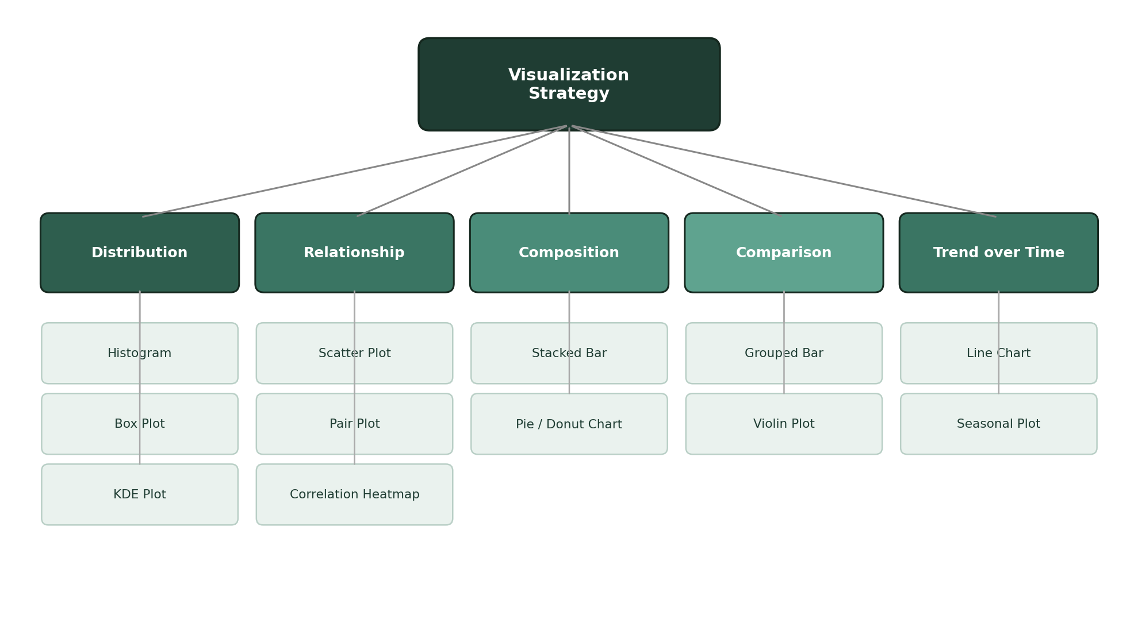
Figure 1: Visualization strategy map — analytical intent to plot type

3.1 Distribution Plots
Histograms and KDE plots reveal the shape of a single variable's distribution (e.g., is yield normally distributed, or skewed?), while box plots concisely summarize the median, quartiles, and outliers side by side across categories such as crop type.

3.2 Relationship Plots
Scatter plots visualize how two continuous variables move together (e.g., rainfall vs. yield), pair plots extend this across every numeric column at once, and correlation heatmaps give a compact, color-coded summary of all pairwise relationships.

3.3 Composition & Comparison Plots
Stacked bar charts show how a whole breaks down into parts (e.g., crop area share by district), while grouped bar and violin plots compare a metric across discrete categories (e.g., yield distribution by soil type).

3.4 Trend Plots
Line charts and seasonal decomposition plots track how a variable evolves across time — essential for spotting multi-year climate trends that a single-season snapshot would miss.

4. Tools and Libraries
The following Python libraries form the core visualization and analysis toolkit for this framework, each contributing a distinct capability to the overall workflow.
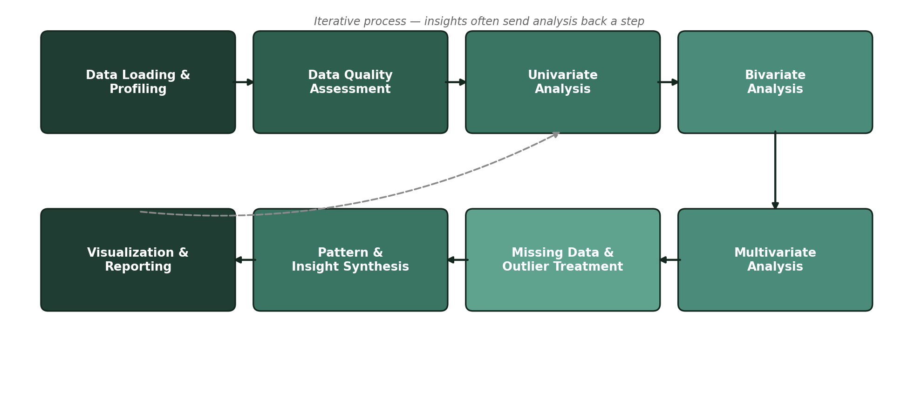
Figure 2: End-to-end EDA workflow, from data loading to reporting
Library | Role in EDA | Example Use in This Project
pandas | Data loading, profiling, grouping and summary statistics | .describe(), .groupby() to summarize yield by district and season
NumPy | Numerical operations, array-based transformations | Computing z-scores for outlier detection on rainfall readings
matplotlib | Base plotting engine for static charts | Histograms of yield distribution per crop type
seaborn | Statistical visualizations with cleaner defaults | Correlation heatmaps between weather variables and yield
plotly | Interactive charts for deeper drill-down exploration | Interactive time-series plot of rainfall trends across years
missingno | Visualizing missing-data patterns | Matrix plot to spot which districts have incomplete soil records
Table 2: Python libraries mapped to their role in the EDA process

5. Reporting and Documentation Plan
Findings from the EDA phase would be consolidated into a structured internal report, organized to support both technical review and quick stakeholder consumption:
- Data Overview: dataset shape, column definitions, and data quality summary.
- Key Distributions: annotated histograms and box plots for the most important variables, with plain-language takeaways beneath each.
- Relationship Findings: correlation heatmap plus 2–3 scatter plots highlighting the strongest predictors of yield.
- Data Quality Log: a running record of every missing-value or outlier decision made, and why — for reproducibility and audit purposes.
- Next-Step Recommendations: which features look most promising for modeling, and which data gaps should be prioritized for collection.
This report would be maintained as a living Jupyter Notebook during development, then exported to a clean, narrative-style document (or slide summary) once the analysis stabilizes — ensuring both reproducibility and readability for non-technical stakeholders.

6. Conclusion
This framework establishes a repeatable, dataset-agnostic approach to exploratory data analysis — pairing each analytical question with the right technique and the right visualization. Applied to the crop yield context, it would surface the weather and soil factors most predictive of yield well before any model is trained, ensuring that the modeling phase in later weeks builds on a foundation of validated, well-understood data.

